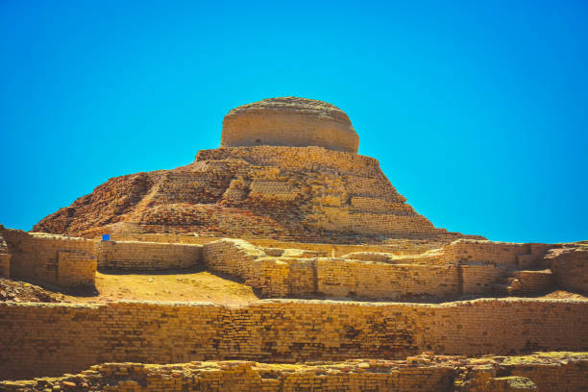

**MOHENJ0N DARO**

**Explore the Ancient Marvel of Mohenjo-Daro**

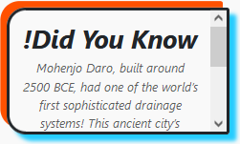Mohenjo-Daro, a UNESCO World Heritage Site, is one of the most remarkable archaeological discoveries in the world. Located in Sindh, Pakistan, this ancient city dates back to around 2500 BCE and was a prominent part of the Indus Valley Civilization. Known for its advanced urban planning, Mohenjo-Daro featured a sophisticated drainage system, well-structured streets, and impressive architectural designs that were far ahead of their time. Walking through its ruins, visitors can witness remnants of this once-thriving metropolis, from the Great Bath to the intricate residential areas. Mohenjo-Daro stands as a testament to the ingenuity and cultural achievements of one of the world’s earliest civilizations.

# Mohenjo-Daro: A Glimpse into a Lost Civilization

Step back in time to explore Mohenjo-Daro, an ancient city

that once thrived over 4,500 years ago. This site is a window into

the lives of the people of the Indus Valley Civilization, showcasing their advancements in urban planning, trade, and daily life. The city’s grid-like streets, brick-lined wells, and elaborate drainage system reveal a highly organized society with a deep understanding of infrastructure. As you explore the ruins, you’ll uncover mysteries of a civilization that mysteriously disappeared, leaving behind a legacy of innovation and cultural heritage. Mohenjo-Daro is not just an archaeological site; it’s a journey into the origins of human history.

**Unraveling the Mysteries of Mohenjo-Daro**

Mohenjo-Daro remains one of the greatest enigmas of the ancient world. Despite its incredible urban development and flourishing trade networks, the city’s decline and the disappearance of its inhabitants continue to puzzle historians and archaeologists. Visitors to the site can explore its carefully planned streets, large granaries, and public baths, each offering clues to the daily lives of its residents. Mohenjo-Daro’s artifacts, including seals, pottery, and statues like the iconic "Dancing Girl," shed light on the art and culture of this ancient civilization. It is a place that sparks curiosity and invites exploration, leaving visitors fascinated by its rich history and unanswered questions.

**Why Mohenjo-Daro is a Treasure of Human History**

Mohenjo-Daro is not just an archaeological site; it is a symbol of human ingenuity and resilience. This ancient city, built with remarkable precision, stands as a reminder of how advanced the Indus Valley Civilization was in areas such as engineering, trade, and governance. The Great Bath, a sophisticated water tank, highlights their understanding of public infrastructure, while the standardized brick sizes reflect their mastery of construction. Visiting Mohenjo-Daro is an opportunity to witness a civilization that contributed significantly to the foundation of modern urban living. It’s a treasure trove of history and a testament to the creativity and intelligence of our ancestors.

# ENJOYABLE ACTIVITIES

# 

! Bring your camera to document the ruins and the scenic landscape surrounding this UNESCO World Heritage Site. It's a perfect blend of history and picturesque views.

! Visit the onsite museum to view ancient artifacts, including tools, pottery, and the famous Dancing Girl statue, offering a glimpse into the daily life of Mohenjo Daro’s inhabitants.

! Walk through the meticulously planned streets, marvel at the Great Bath, and observe the intricate brickwork that showcases the ingenuity of the Indus Valley Civilization.

**Mohenjo-Daro: A Cradle of Ancient Civilization**

* Mohenjo-Daro, located in the Sindh province of Pakistan, is one of the most iconic remnants of the Indus Valley Civilization, dating back to approximately 2500 BCE. This ancient city, whose name translates to "Mound of the Dead," is a marvel of early urban planning and engineering. With meticulously designed streets, advanced drainage systems, and impressive public structures like the Great Bath, Mohenjo-Daro showcases the ingenuity and sophistication of one of the world's earliest civilizations. Visitors can explore its ruins, including residential areas, marketplaces, and granaries, all of which reflect a highly organized and flourishing society. Today, Mohenjo-Daro stands as a symbol of human innovation and remains a priceless archaeological treasure for understanding ancient cultures.

**Step into History at Mohenjo-Daro**

* Mohenjo-Daro offers a fascinating journey into the past, where visitors can witness the remains of a city that thrived over 4,500 years ago. As a hub of the Indus Valley Civilization, this ancient metropolis was renowned for its remarkable infrastructure, including standardized brick construction, a well-planned grid layout, and an intricate water management system. Artifacts discovered at the site, such as pottery, seals, and statues like the famous "Dancing Girl," provide glimpses into the cultural and artistic achievements of its people. Beyond its historical significance, Mohenjo-Daro is a testament to the ingenuity and resilience of human societies. Walking through its ruins is like stepping back in time, offering a unique opportunity to connect with one of the earliest chapters of human civilization.

# LOCATION

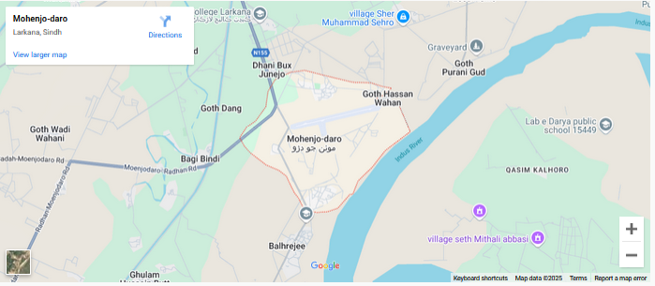

Mohenjo-daro is an ancient archaeological site located in the Sindh province of Pakistan, near the Indus River. It is one of the key settlements of the Indus Valley Civilization and is situated about 28 kilometers west of the city of Larkana. The site dates back to around 2500 BCE and is known for its well-planned urban layout.

# Why Visit Mohenjo Daro?

**Explore the wonders of the ancient Indus Valley Civilization at Mohenjo Daro. This 4,500-year-old city showcases advanced urban planning, remarkable artifacts, and a glimpse into one of humanity’s earliest societies—a must-visit for history lovers and curious travelers!**

# FEATURED PRODUCT